**In** this investigation a process for measuring the relationship between two variables is examined. The measure is called the *q*-correlation coefficient.

To calculate the *q*-correlation coefficient

* Plot a scatter graph for the two variables.
* Determine the median for the values on the horizontal (*x*) axis.
* Determine the median for the values on the vertical (*y*) axis.
* Divide the region where the points occur into 4 quadrants by
  + Drawing a vertical line where *x* = median of values on the horizontal axis
  + Drawing a horizontal line where *y* = median of values on the vertical axis
* Label the quadrants e.g. A, B, C and D in the positions as shown on the graph below. The top right quadrant is always A, the top left is B, bottom left is C and bottom right is D.
* Count the points in each quadrant (do not count points on the dividing lines).
* Use the rule *q*-correlation coefficient = $\frac{\left(a+c\right)- (b+d)}{a+b+c+d}$ where *a* represents the number of points in quadrant A, *b* represents the number of points in quadrant B, *c* represents the number of points in quadrant C, and *d* represents the number of points in quadrant D.

Example: M1 and M2 represent the scores of ten students in two mental Maths tests.

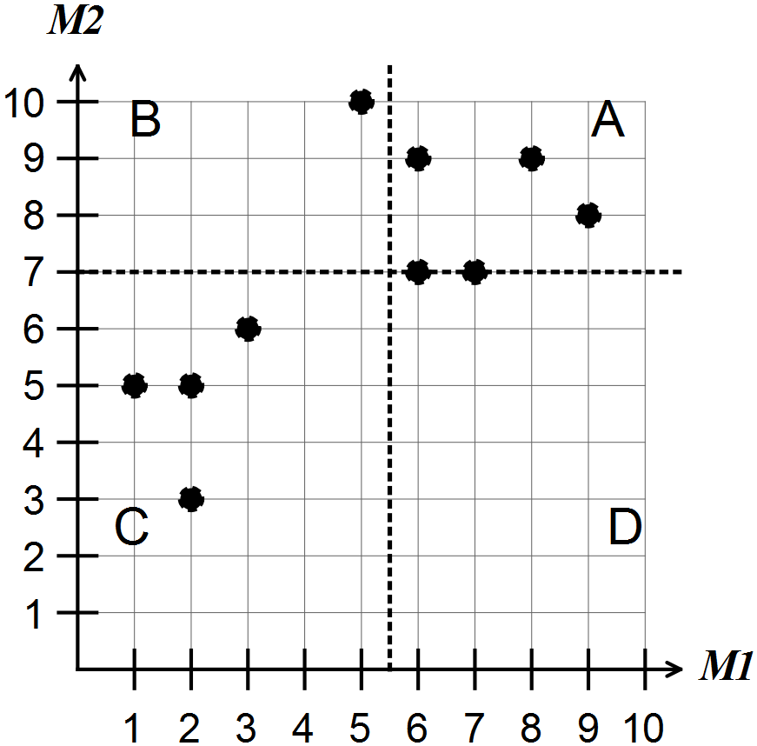

For the scatter graph shown above

* the median of M1 is 5.5
* the median of M2 is 7
* there are 3 points in A so *a* = 3. Similarly *b* = 1, *c* = 4, *d* = 0.

The points (6,7) and (7,7) are on a line and not counted in any quadrants.

Hence, the *q*-correlation coefficient is equal to 

Note: Give *q*-correlations as fractions and decimals.